UNIT-V TIME BASE GENERATORS:
- General features of Time base signal
- Methods of generating Time base waveforms
- Concepts of transistor Miller and Bootstrap time base generators
- Methods of linearity improvement
Time base Generators or Sweep generators:
- A time-base generator is an electronic circuit which generates an output voltage or current waveform, a portion of which varies linearly with time.
- Ideally the output waveform should be a ramp.
- Time-base generators are two types.
  - Voltage time-base generators
  - Current time-base generators.
- A voltage time-base generator is one that provides an output voltage waveform, a portion of which exhibits a linear variation with respect to time.
- A current time-base generator is one that provides an output current waveform, a portion of which exhibits a linear variation with respect to time.
Applications of time-base generators: CROs, television and radar displays, in precise time measurements, and in time modulation.

The most important application of a time-base generator is in CROs. To display the variation with respect to time of an arbitrary waveform on the screen of an oscilloscope it is required to apply to one set of deflecting plates a voltage which varies linearly with time. Since this waveform is used to sweep the electron beam horizontally across the screen it is called the sweep voltage and the time-base generators are called the sweep circuits.

General features of Time base signal:
- As seen the voltage starting from some initial value increases linearly with time to a maximum value after which it returns again to its initial value. The time during which the output increases is called the sweep time and the time taken by the signal to return to its initial value is called the restoration time, the return time, or the flyback time.
Figure (a) General sweep voltage and (b) saw-tooth voltage waveforms

Errors of Sweep Signals
After generating the sweep signals, it is time to transmit them. The transmitted signal may be subjected to deviation from linearity. To understand and correct the errors occurred, we must have some knowledge on the common errors that occur.

The deviation from linearity is expressed in three most important ways:

1. The slope or sweep speed error, es
2. The displacement error, ed
3. The transmission error, et
The slope or sweep-speed error, es:
An important requirement of a sweep is that it must increase linearly with time, i.e. the rate of change of sweep voltage with time must be constant. This deviation from linearity is defined as

The displacement error, ed:
Another important criterion of linearity is the maximum difference between the actual sweep voltage and the linear sweep which passes through the beginning and end points of the actual sweep.
The displacement error ed is defined as

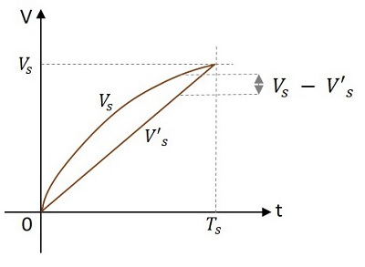
As shown in Figure above vs is the actual sweep and v's is the linear sweep

The transmission error, et:
When a ramp signal is transmitted through a high-pass circuit, the output falls away from the input as shown in below Figure. This deviation is expressed as transmission error et, defined as the difference between the input and the output divided by the input at the end of the sweep

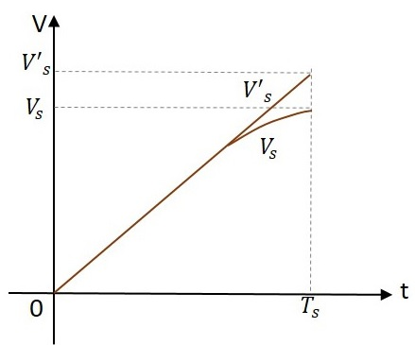
where as shown in Figure above, V's is the input and Vs is the output at the end of the sweep, i.e. at t = T_{S}

If the deviation from linearity is small so that the sweep voltage may be approximated by the sum of linear and quadratic terms in t, then the above three errors are related as
which implies that the sweep speed error is the more dominant one and the displacement error is the least severe one.
METHODS OF GENERATING A TIME-BASE WAVEFORM:
In time-base circuits, sweep linearity is achieved by one of the following methods.

1. Exponential charging: In this method a capacitor is charged from a supply voltage through a
resistor to a voltage which is small compared with the supply voltage.

2. Constant current charging: In this method a capacitor is charged linearly from a constant current source. Since the charging current is constant the voltage across the capacitor increases linearly.

3. The Miller circuit: In this method an operational integrator is used to convert an input step voltage into a ramp waveform.

4. The Phantastron circuit: In this method a pulse input is converted into a ramp. This is a modified version of the Miller circuit.

5. The bootstrap circuit: In this method a capacitor is charged linearly by a constant current which is obtained by maintaining a constant voltage across a fixed resistor in series with the capacitor.

6. Compensating networks: In this method a compensating circuit is introduced to improve the
linearity of the basic Miller and bootstrap time-base generators.

7. An inductor circuit: In this method an RLC series circuit is used. Since an inductor does not allow the current passing through it to change instantaneously, the current through the capacitor more or less remains constant and hence a more linear sweep is obtained.

EXPONENTIAL SWEEP CIRCUIT

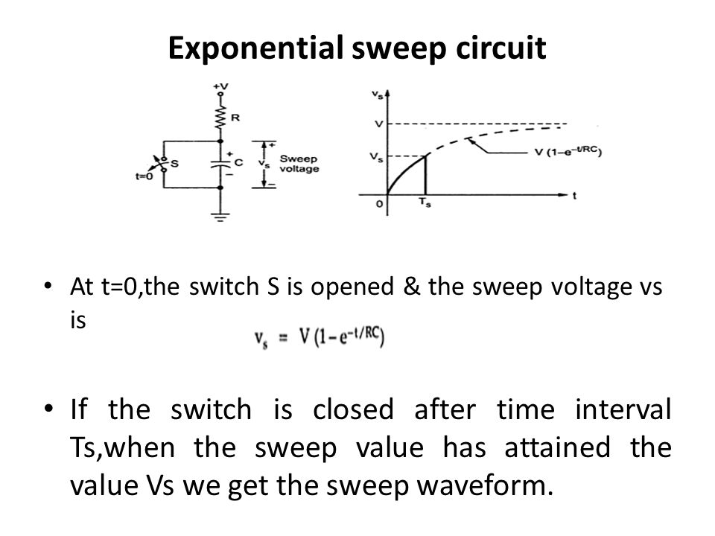

Figure shows an exponential sweep circuit. The switch S is normally closed and is open at t = 0. So for t > 0, the capacitor charges towards the supply voltage V with a time constant RC. The voltage across the capacitor at any instant of time is given by 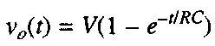 After an interval of time Tx when the sweep amplitude attains the value Vs, the switch again closes.

Bootstrap Time Base Generator:

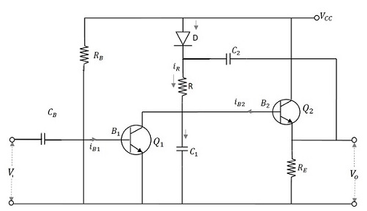

Construction:
- The boot strap time base generator circuit consists of two transistors.
- Q₁ acts as a switch and Q₂ acts as an emitter follower.
- The transistor Q₁ is connected using an input capacitor C_{B} at its base and a resistor R_{B} through V_{CC}.
- The collector of the transistor Q₁ is connected to the base of the transistor Q₂.
- The collector of Q₂ is connected to V_{CC} while its emitter is provided with a resistor R_{E} across which the output is taken.
- A diode D is taken whose anode is connected to V_{CC} while cathode is connected to the capacitor C₂ which is connected to the output.
- The cathode of diode D is also connected to a resistor R which is in turn connected to a capacitor C₁. This C₁ and R are connected through the base of Q₂ and collector of Q₁.
- The voltage that appears across the capacitor C₁ provides the output voltage V_{o}.

Operation:
- Before the application of gating waveform at t = 0, as the transistor gets enough base drive from V_{CC} through R_{B}, Q₁ is ON and Q₂ is OFF.
- The capacitor C₂ charges to V_{CC} through the diode D.
- Then a negative trigger pulse from the gating waveform of a Monostable Multivibrator is applied at the base of Q₁ which turns Q₁ OFF.
- The capacitor C₂ now discharges and the capacitor C₁ charges through the resistor R.
- As the capacitor C₂ has large value of capacitance, its voltage levels (charge and discharge) vary at a slower rate. Hence it discharges slowly and maintains a nearly constant value during the ramp generation at the output of Q₂.
- During the ramp time, the diode D is reverse biased. The capacitor C₂ provides a small current I_{C1} for the capacitor C₁ to charge.
- As the capacitance value is high, though it provides current, it doesn’t make much difference in its charge. When Q₁ gets ON at the end of ramp time, C₁ discharges rapidly to its initial value.
- This voltage appears across V_{O}. Consequently, the diode D gets forward biased again and the capacitor C₂ gets a pulse of current to recover its small charge lost during the charging of C₁. Now, the circuit is ready to produce another ramp output.
- The capacitor C2 which helps in providing some feedback current to the capacitor C1 acts as a boot strapping capacitor that provides constant current.

Output Waveforms
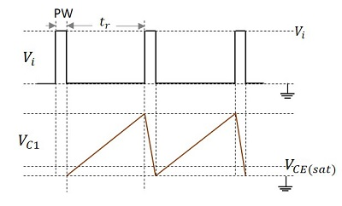

Advantage
The main advantage of this boot strap ramp generator is that the output voltage ramp is very linear and the ramp amplitude reaches the supply voltage level.

THE TRANSISTOR MILLER TIME-BASE GENERATOR:
- Q1 acts as a switch and Q2 is High gain amplifier.
- Q1 is ON and Q2 is OFF. Voltage across Cs & output is equal to Vcc.
- If the base of Q1is R_{B}, is reverse biased then Q1 turn off and Q2 then ON. As Q2 conducts output slowly becomes zero
- As Cs is coupled to base of resistor Q2., then the rate of decrease of output voltage is determined by the rate of discharge of capacitor. T=RC
- If T is very large then discharge current will be constant.
- Q1 turns ON and Q2 turns OFF when input pulse will be removed. Then Cs charges to Vcc through resistor Rc2 having a time constant RC.
- Miller sweep circuit offers excellent linearity.

